Meltdown Attack Lab

**3 Tasks 1 and 2: Side Channel Attacks via CPU Caches**

Both the Meltdown and Spectre attacks use CPU cache as a side channel to steal a protected secret. The technique used in this side-channel attack is called FLUSH+RELOAD. We will study this technique first. The code developed in these two tasks will be used as a building block in later tasks.

**3.1 Task 1: Reading from Cache versus from Memory**

I compiled the given program using the parameter -march with value native, that tells the compiler to enable all instruction subsets supported by the local machine. Next, on executing:

After executing 10 times, we see that, initially, the CPU cycles for all the data access were the same, and hence differentiating between memory access and cache access was not possible. However, we also notice that in certain executions, the CPU cycle time for accessing 3rd and 7th block was as low as 40 cycles. Because the access from cache is faster than from main memory, this clearly indicated that the content was fetched from the cache and not the memory,. To set a threshold, to decide if the memory block was fetched from the cache or the main memory, I consider a value of 100 CPU cycles, because none of the main memory accesses fell below that (lowest was 104 for 0th block), and on executing the same program multiple times, I noticed that the CPU cycles for accessing 3rd and 7th block reached as high as 100. Therefore, the threshold value considered for this lab would be 100 to distinguish between cache or main memory access.

**3.2 Task 2: Using Cache as a Side Channel**

I compiled the given program using the parameter -march with value native, that tells the compiler to enable all instruction subsets supported by the local machine. Next, on executing:

﻿gcc -march=native FlushReload.c -o FlushReload

I first change the given program to set the threshold value as 100. On running the given program 20 times, we see that the secret is identified 17 times, and misses only 3 times. Also, the secret identified is 94 only and not any other array value, verifying no main memory access was completed in less than 100 CPU cycles, hence assuring that the threshold set for the distinguishing purpose is effectual.

**4 Tasks 3-5: Preparation for the Meltdown Attack**

Memory isolation is the foundation of system security. In most operating systems, kernel memory is not directly accessible to user-space programs. This isolation is achieved by a supervisor bit of the processor that defines whether a memory page of the kernel can be accessed or not. This bit is set when CPU enters the kernel space and cleared when it exits to the user space [3]. With this feature, kernel memory can be safely mapped into the address space of every process, so the page table does not need to change when a user-level program traps into the kernel. However, this isolation feature is broken by the Meltdown attack, which allow unprivileged user-level programs to read arbitrary kernel memory.

**4.1 Task 3: Place Secret Data in Kernel Space**

Compilation and execution.

I had downloaded the code from the lab website, and go to the directory that contains Makefile and MeltdownKernel.c. Type the **make** command to compile the kernel module. To install this kernel module, use the insmod command. Once I have successfully installed the kernel module, I can use the dmesg command to find the secret data’s address from the kernel message buffer. Take a note of this address, as I need it later.



Here I compile the kernel module using the Makefile and install the compiled file using the insmod command. This module stores the secret data in the kernel and also caches it in order to increase the success rate of the attack. It also allows us to find the address location at which our secret is stored using the publicly accessible message buffer. To find the secret data’s address, we use the dmesg command as follows:

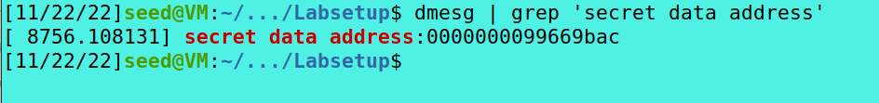

We get that the secret data is stored at ﻿**0000000099669bac**. We will be using this address to extract the secret kernel data using the meltdown attack.

**4.2 Task 4: Access Kernel Memory from User Space**

Now I know the address of the secret data, let us do an experiment to see whether we can directly get the secret from this address or not. I can write your own code for this experiment. They provide a code sample in the following. For the address in Line ➀, I should replace it with the address obtained from the previous task.

We write the following code to check if we can get the data that is stored at the location obtained from the previous task, that of the secret:

I compile and run the program and see that there is a segmentation fault error, indicating that we were not successful in getting the data stored at the address directly, even though we knew the right address of the secret.

The access control logic inside the CPU doesn’t allow the user-level program to get into the kernel space and the kernel memory is not directly accessible to the user-space programs. This program crashes with a segmentation fault error because our program is a user-level program, which cannot access the kernel memory. Hence, the Line 2 had an interruption while executing.

**4.3 Task 5: Handle Error/Exceptions in C**

I compiled the given program using the parameter -march with value native, that tells the compiler to enable all instruction subsets supported by the local machine. Next, on executing:

Here I compile and run the given Exception handling program and observe that even though I were accessing the kernel space; the program continued to run and did not crash. This was possible due to the program handling the exception raised by the event of accessing the kernel memory from a user-space and avoiding the OS to handle the fault which would have led it into killing the program, just like before. Thus, handling the exception allowed the program to run and not crash, and it just prints out the error message.

**5 Task 6: Out-of-Order Execution by CPU**

As we have seen before, if a particular memory is accessed then the CPU stores it in its cache. Using the CPU cycle, we were able to find a threshold value to distinguish between memory accesses – from the cache or the main memory. We use this value to find if a particular memory block was accessed from the cache or the main memory in our program. After setting the threshold value as 100 and the kernel secret address as the one found in Task 3, we compile and run the given program:



I see that the program has successfully executed without any “Segmentation Fault” errors because I handle the exception raised due to the kernel memory access. From the execution results, I can see that the array [7 * 4096 + 1024] is indeed in the CPU cache. That means that the line, after the instruction that caused the exception due to memory access violation, was executed; otherwise, the array would not have been in the cache. Since I was trying to access the kernel memory as a user program, I raised an exception that caused the Memory Access Violation to be printed out. But due to out-of-order execution, the next line was executed before the first line completed its execution – that of access check. Everything was cleared due to failed access check, but not the cache, and hence the cache proved that the second line was executed.

**6 Task 7: The Basic Meltdown Attack**

As we know, Meltdown is a race condition vulnerability, which involves the racing between the out of order execution and the access check. The out of order execution provides us with an opportunity to read the kernel data by storing it in the cache, which is not cleared on a failed access check. We now try to read the kernel data using different approaches.

**6.1 Task 7.1: A Naive Approach**

We now replace 7 with ‘kernel_data’, that is the secret stored in the kernel space. By finding the particular array that was cached, we can confirm that the kernel_data is the value of k in the memory block - array [k*4096 + 1024]. We modify the code and run the program:

As we run the program multiple times, we see that the attack is not successful since we were not able to find the cached array. As before, due to out-of-order execution, the array with location

value as secret should have been stored in the cache, even though the access to the kernel data would fail. But as we see, since nothing is cached, the attack was not successful.

**6.2 Task 7.2: Improve the Attack by Getting the Secret Data Cached**

The issue before was that since we were exploiting the race condition between the access check and out-of-order execution, the attack will not be successful if the access check occurs before we were able to read the kernel data, because the program will raise the exception before even going to the next instruction. So, for a successful attack, we need to load the kernel data faster than the access check. To do so, we preload the kernel data into the cache, so that the data access is faster, and the next instruction can be executed due to the out-of-order execution. We add the code to read the kernel data before the out-of-order execution commands, as seen in the following:

Then I compile and run the program, and observe that we are still unsuccessful in getting the secret data stored in the kernel memory:



**6.3 Task 7.3: Using Assembly Code to Trigger Meltdown**

Since we were unsuccessful before, we then change the code so that we call the meltdown_asm function instead of meltdown. After compiling and executing the program multiple times, we make the following observations:

I see that the attack is successful sometimes, but the probability is low. The secret data that we stored is 0 – ASCII value of S, which is the first letter of the secret message stored in the kernel, as seen in the output. On increasing the loop from 400 to 500, I notice that there is not much of a change in the probability of successful attack. Even after running the program multiple times, the results were similar to that as before. On decreasing the loop from 500 to 200 next, I see similar results as before, with no increase in the probability of a successful attack. Hence this proved, even though the loop was slowing the memory access check by giving the algorithmic units to run something else, the number of times the loop ran did not really matter. The next page shows the screenshots of the result:

Output with a loop of 500

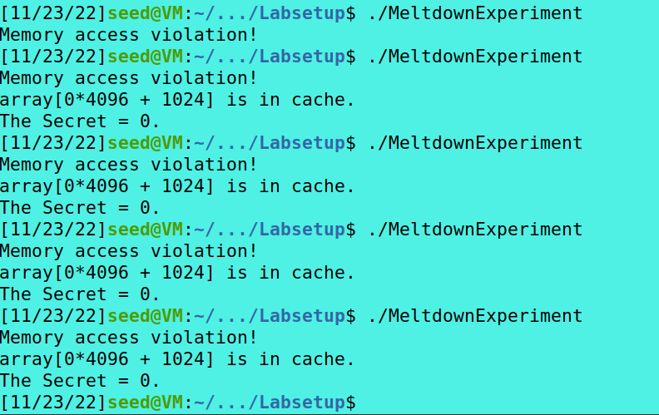

Output with a loop of 200

**7 Task 8: Make the Attack More Practical**

After changing the threshold value and secret message address in the MeltdownAttack.c file, we compile and run the program, and get the following:

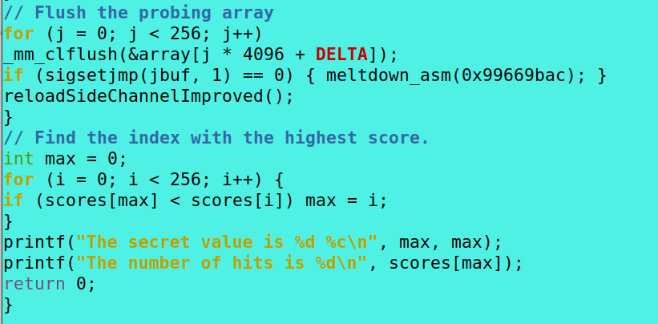

After changing the threshold value and secret message address in the MeltdownAttack.c file, we compile and run the program, and get the following:

We see that the attack is successful, and we get the first character of the secret message S stored in the kernel with the number of hits as 58 out of 1000. In order to get all the 8 bytes of the secret The following is the output of running the same program.

Thus, we have successfully performed the Meltdown attack and obtained the Secret value stored in the kernel space – SEEDLabs.